**Special Notes:**

1. Use the following format for your project name: **PC_[PARTICIPANT ID]**, example: PC_01 or PC_10.
2. You must submit the whole project and ensure that the project can be run in another machine (PC) without additional configuration. Please pay attention to your database connection string!
3. In the event you fail to submit the proper project that causing the project cannot be compiled, no score will be given.
4. You are not allowed to modify or alter the structure of the given database. However, you can insert additional record.
5. Marking process will be done using the original given database with added records.

Mandheg Parking System

**Mandheg Parking System** is a new application aimed to help manage parking system in several shops. As the newly appointed developer, you are tasked to create the Desktop Application. Given along the projects are SQL File for the database (attached in separated file), Entity Relationship Diagram, and detail of each features requested.

# Entity Relationship Diagram (ERD)

The following is the ERD of **Mandheg Parking System**.

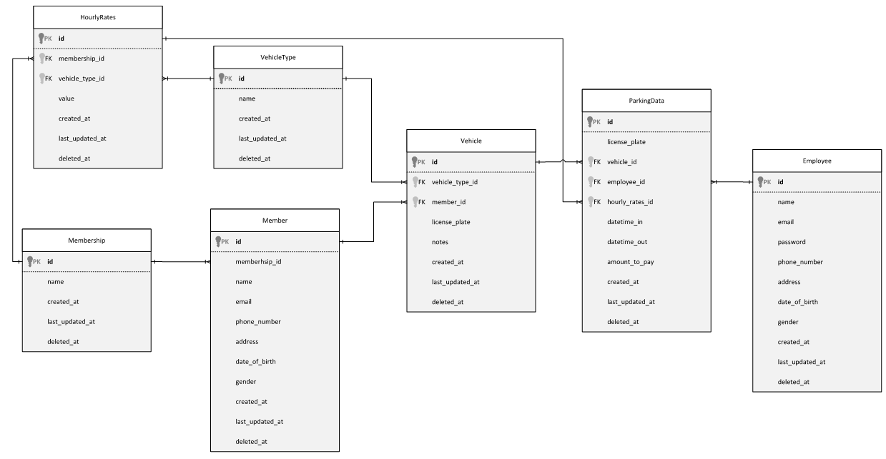

**Figure 1. ERD of Mandheg Parking System**

# Login Form

* + Login form is used by the staff to access menu inside the system. Validate that the login information exists in the database. Display proper error message if necessary.
  + Pay attention that all password field is already hashed using **SHA256 Algorithm**.
  + 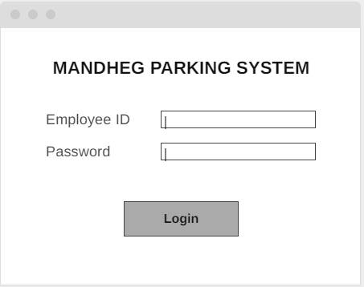**The first employee record password is ‘admin’.**

**Figure 2. Login Form**

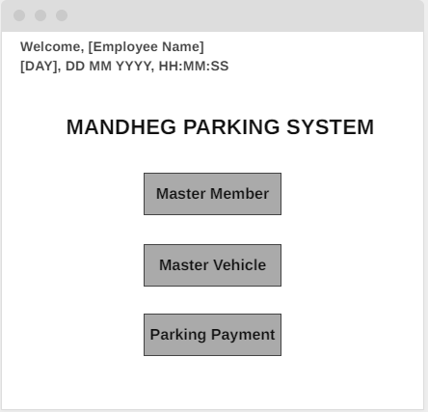If the login is success, then staff will be redirected to main form.

**Figure 3. Main Form**

# Master Member

* + Master Member form is used to manage member of the parking area. If one of the records is clicked, display detail of the record into each corresponding component. Any data cannot be modified during this time.
  + When button Insert is clicked, clear all data from each component. Staff then can fill in the component with the new member data.
  + When button Update is clicked, the selected member data can be modified via the component.
  + When button Delete is clicked, the selected member data will become target of the removal.
  + When button Submit is clicked, depends on the previous action (Insert, Update, or Delete), the action will be executed. Note that insert and update required proper data validation. Delete process requires a confirmation by the staff.
  + When button Cancel is clicked, reset the form into original condition and cancel all previous action.

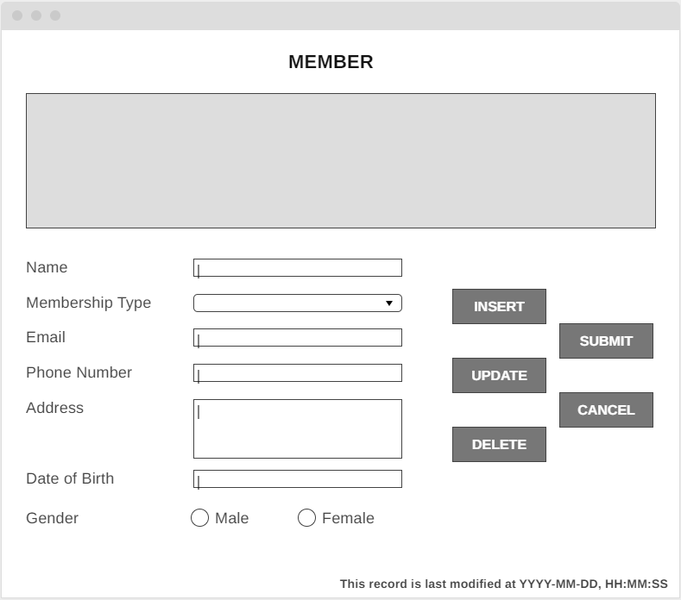

**Figure 4. Master Member Form**

# Master Vehicle

* + Master Vehicle form is used to manage registered vehicle of the member. If one of the records is clicked, display detail of the record into each corresponding component. Any data cannot be modified during this time. Special notes on Owner Field, data shown here should be in the format of [Member ID] – [Member Name].
  + Staff can search the vehicle records by using Owner Name or License Plate. This can be chosen by using given dropdown in search area.
  + When button Insert is clicked, clear all data from each component. Staff then can fill in the component with the new vehicle data. Special notes on Owner Feld, this field can only be filled by auto complete.
  + When button Update is clicked, the selected vehicle data can be modified via the component. Special notes on Owner Field, this field can only be filled by auto-complete features.
  + When button Delete is clicked, the selected vehicle data will become target of the removal.
  + When button Submit is clicked, depends on the previous action (Insert, Update, or Delete), the action will be executed. Note that insert and update required proper data validation. Delete process requires a confirmation by the staff.
  + When button Cancel is clicked, reset the form into original condition and cancel all previous action.

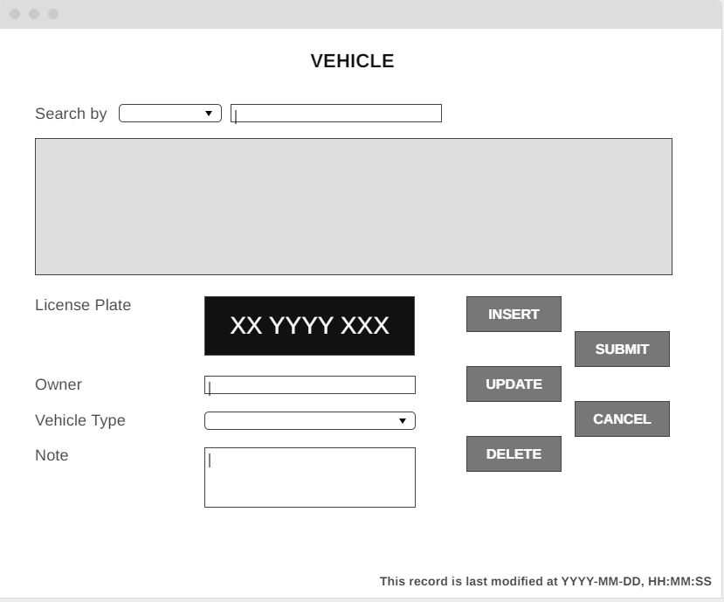

**Figure 5. Master Vehicle Form**

# Parking Payment

* + Parking Payment form is used to calculate parking fee and store the payment data. Staff needs to entry the license plate number, then the system will check whether the vehicle belongs to member or not.
  + Staff also need to entry IN and OUT time, make sure to give proper validation regarding this.
  + Vehicle type can be chosen only if the vehicle does not belong to a member, otherwise staff can choose the vehicle type.
  + Hourly parking fee will vary based on whether the vehicle belongs to member or not. Also, the calculation is based on number of hour (rounded-up) the vehicle is parked.
  + If button submit is clicked, the payment data will be stored.

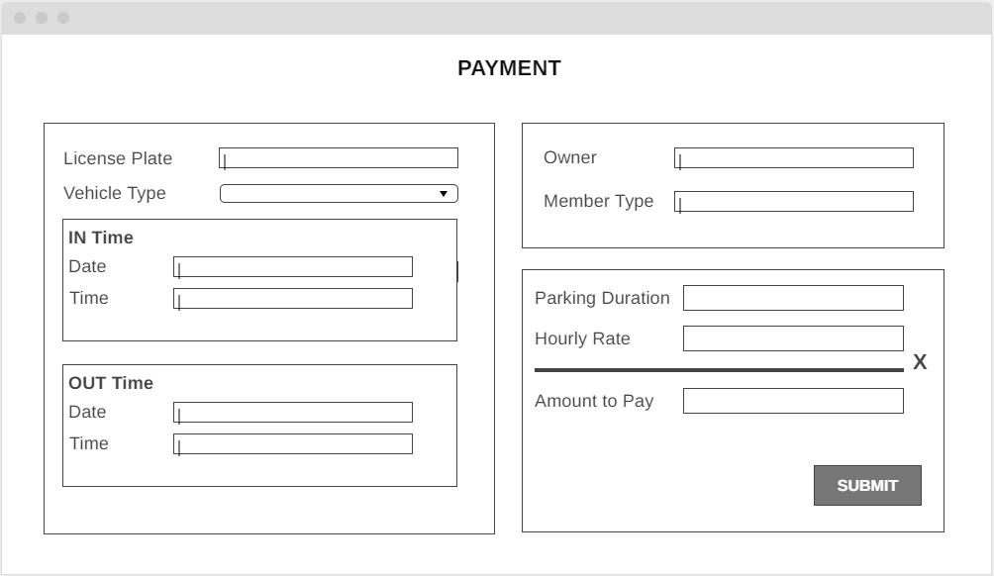

**Figure 6. Parking Payment Form**